**Introduction To Gear Ratios.**

Now that you have experience building your first car, you might be wondering how you could possible alter your hardware design to make it move faster or have more torque. The answer to both these inquiries is gears or actually the combination of gears.

Introduction to gear ratios.

By combining different sized gears in series you can create different gear ratios, which is the comparison of how many rotations of one gear to another, in the form of a fraction or a signal decimal number. The larger the decimal number the faster the driven gear will rotate, the lower the decimal the slower it will rotate, but it will have greater torque. Torque is the tendency of a force to rotate an object about a given axis, or in other words greater power to turn the wheel.

So, if you wanted your little car to have a high top speed what type of gear ratio would you want? What if you wanted your car to have the ability to pull a bunch of weight? To answer these questions you are going to experiment by building cars to accomplish both of these tasks. But first you need to know how to calculate your own gear ratios.

How to calculate gear ratios.

In order to calculate gear ratios, you need to know a few definitions first.

**Drive Gear**: is the gear attached to the motor shaft.

**Driven Gear:** Is the gear attached to the load, or in this the wheel.

**Idler Gears:** Are gears in between the Drive and Driven gears.

**Simple Gear Chain:** Is the whole combination of gears that begins with the Drive Gear and ends with the Driven Gear.

**Series Gear Chain:** When the gears connected in a straight line.

**Teeth:** The notches in the gears.

To calculate a the gear ratio of a two gear chain all you need to do is divide the number of teeth that the drive gear has by the number of teeth the driven gear has. For example the drive gear has 40 teeth, and the driven gear has 22. The ratio would be 40 \ 22 = 20 \ 11 = 1.81. Meaning that for every 1 turn of the drive gear the driven gear makes 1.81 rotations. Another way of looking at it is to think that for every 11 turns of the drive gear the driven gear will make 20 rotations. Would this gear ratio be considered a high or low gear ratio?

$$\frac{Drive gear teeth}{Driven gear teeth }=Gear ratio$$

$$\frac{40}{22}=\frac{20}{11}=1.81 :1$$

Next what if there was an idle gear in the chain? You can find the ratio of each pair of gears going down from the driven gear and then add, or you can just do what we did when there were just two gears and ignore the idle gear. Find the gear ratio of the following chain, using both methods.



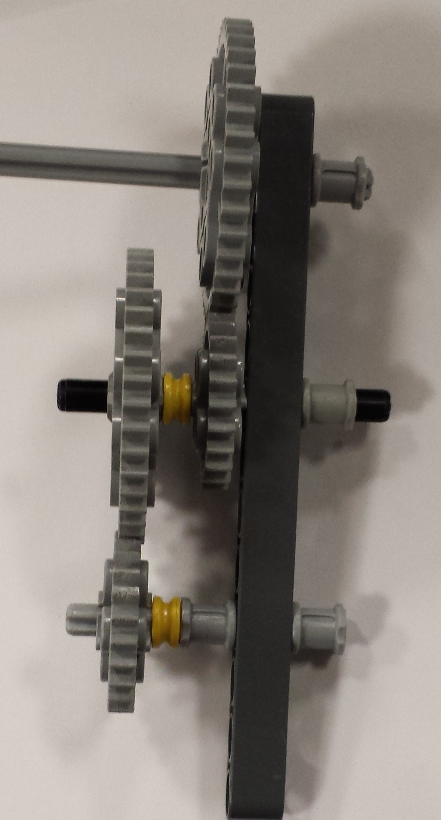The last thing to consider with calculating gear ratios is when you have parallel gears, meaning gears that are on the same axis but are different sizes. For example take the picture below. The top gear in the chain is the drive gear with 40 teeth, and the bottom gear is the driven gear with 15 teeth. Note the idle gears in the middle are parallel to each other, with the left one having 40 teeth and the right one having 15 teeth, so you won’t be able to use the methods you used when the chain was completely in series. So what is the gear ratio of this chain, please include calculations.

**Lab 6.** Speed demon.

Now that you know about gear ratios, you are to build a car that covers a set distance in the hallway as fast as possible. This will focus mostly on the hardware side of things, as such in your lab report please include details about what type of gear ratios you are going to use and why? Also calculate your car’s gear ratio and include them in your report. As for the software side it should be simple for you to figure out by now.

**Lab 7.**  Tank.

Now it is time to take you to build a car that doesn’t focus on speed but rather pulling ability. So your goal is to build a car that can move the most weight a set distance (not far), without regards to time. (please do not make it a snails pass). Like the previous lab record what hardware decisions you made and why. Also include your car’s gear ratio (this includes calculations) and why you choose it to be as it is.

Cliff jumping Saturday Gloucester interested